# Knowledge Evaluation C#

**Problem #1 – The Kitchen Routing System**

**Assumptions**

* There are five defined stations

1. Grill
2. Salad
3. Fry
4. Drink
5. Desert

* RabbitMQ will be used to route notifications to the kitchen stations
* System is one way. Notifications are routed to the kitchen stations. This could be improved later.
* In memory instance of SQL lite will store data

**Overview**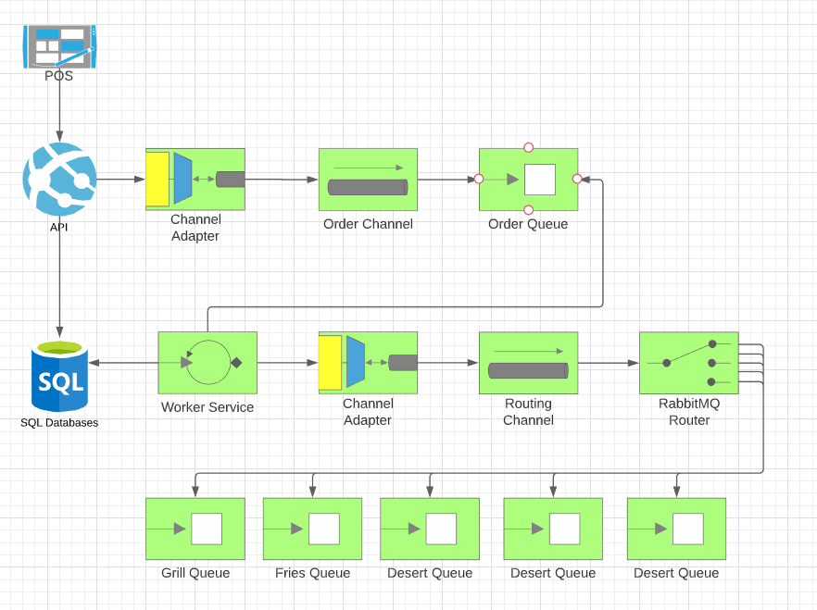

**Authentication**

